**Sprint 4 Report, Detective Dollar**

Detective Dollar Team. Completion by Monday 12/3/23

**Actions to stop doing:**

* We should spend more time early on to address bugs and get the baseline functionality completed.

**Actions to start doing:**

* We should start having in-person programming sessions so we can actively collaborate together and work more efficiently.
* We should start updating completed tasks immediately so the burnup chart more accurately reflects when each task is completed.
* We should start adding comments to our individual code so that when other members start having to work with code they didn’t write, they can more easily understand how to add upon it.

**Actions to keep doing:**

* We should continue to collaborate with one another to resolve bugs in our code.
* We should continue to frequently provide updates through Discord that include videos and visuals that effectively demonstrate the progress that each member has been making.

**Work completed/not completed:**

* Completed User Stories

1. As a user I can add a date to an expense.
2. As a user I can edit an expense.
3. As a user, I can choose a color for a category. 12 default colors.

* Not Completed

4. As a User, I can edit a recurring expense.

**Work completion rate:**

In Sprint 4, the team successfully completed 3 out of 4 user stories.

* Total for User Story 1: Estimated at 6 hours.
* Total for User Story 2: Estimated at 4 hours.
* Total for User Story 3: Estimated at 6 hours.

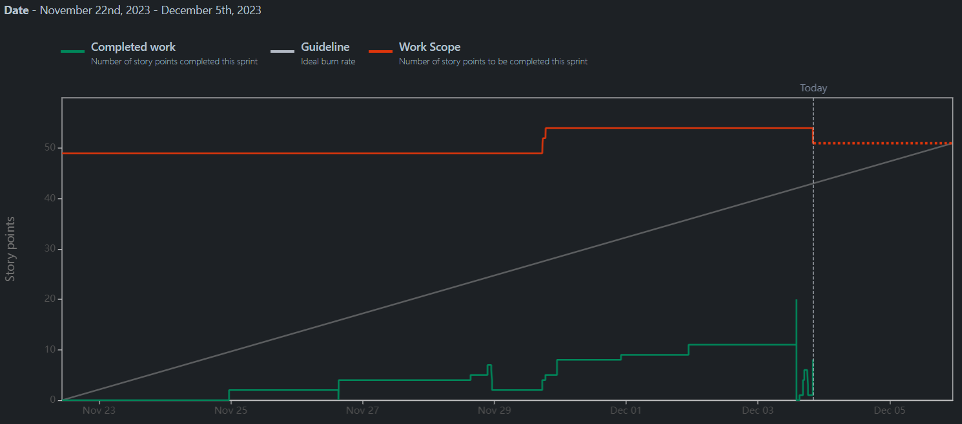

Based on the Burnup chart, we observed that we were behind schedule most of the sprint. This is largely caused by a combination of us not updating our burnup chart immediately, and several tasks being unable to be completed in parallel.